Perfect Flowers

What is required for perfect flowers?

Circle the names of the female structures. Underline the names of the male structures.

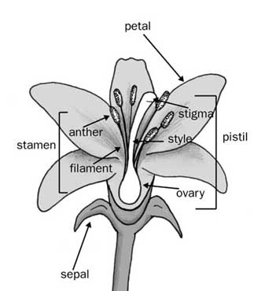

Imperfect Flowers

What makes a flower imperfect?

Label missing plant structures, and label male and female flowers.

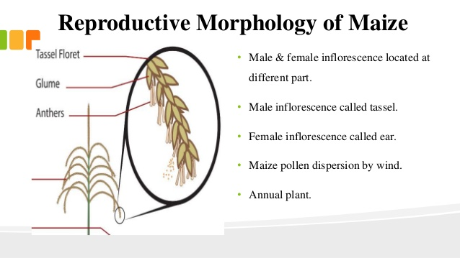

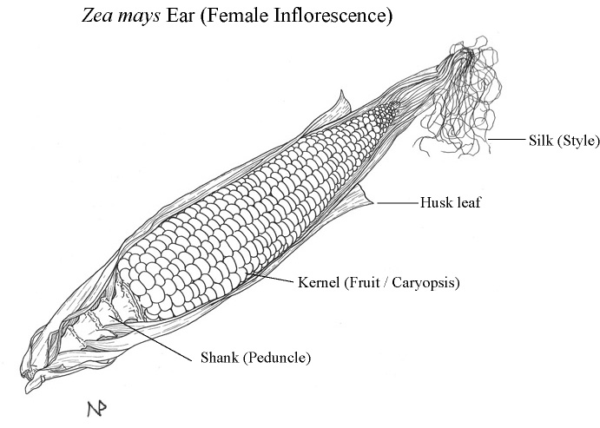

Complete vs. Incomplete Flowers

What four structures are necessary for a complete flower?

Circle necessary structures in the top illustration. What is the missing structure in the bottom illustration?

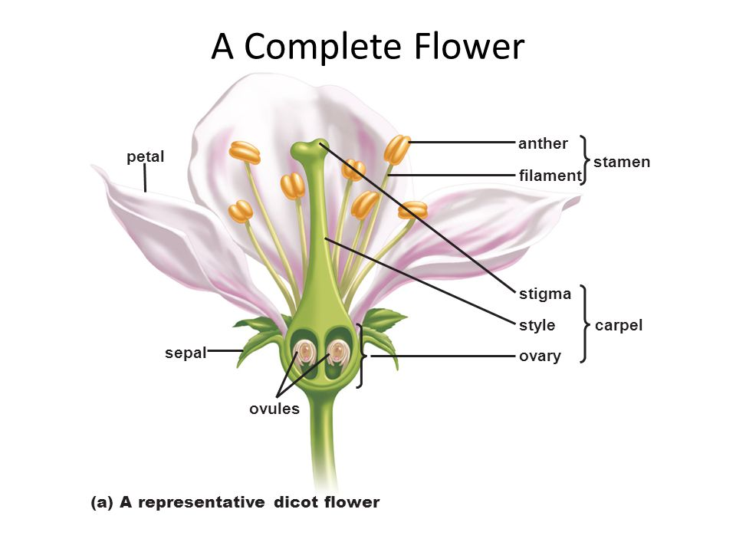

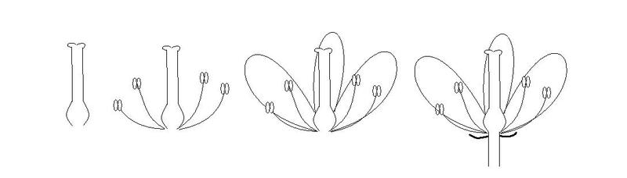

Label all four photos. On the top, write either “perfect” or “imperfect.” Underneath, label either “complete” or “incomplete.”

In the space below, take notes on why this is, or draw additional diagrams.

4

3

1



2